Representative Tina Liebling
477 State Office Building
St. Paul, MN 55155

March 18, 2023

Chair Liebling,

On behalf of RHA (Reproductive Health Alliance), I submit this written testimony in support of changes to the statute outlining the Family Planning Special Projects (FPSP) grant and an increase in funding necessary to accommodate these changes as part of HF2930.

RHA is a coalition of more than 40 reproductive and sexual health clinics, advocacy organizations and individuals across the state of Minnesota. Our clinics are designated as essential community providers by the Minnesota Department of Health. We provide affordable access to medical care including contraception, HIV and STI testing and treatment and evidence based information to the most vulnerable populations across the state.
While the need is growing and STI rates are rising, funding for clinics to address these issues is not keeping up. FPSP funds have increased only 5% since 2001 to the current appropriation of 6.35 million. This doesn’t take into account inflation or wage increases much less the ability for a new clinic or program to access funding.
The current appropriation is inadequate to meet the needs of Minnesotans and to compensate existing grantees. Every grant cycle there are clinics providing important reproductive health services to vulnerable populations (programs for Americans Indians, blind, deaf and hard of hearing and the LGBTQ+ community) that are not funded.
Many of the restrictions and prohibitions have been removed in the proposed changes to the FPSP statute. RHA fully supports these changes to the statute and an increase in funds required to allow for expanded services across Minnesota as well as fair compensation for this important work.

Sincerely,
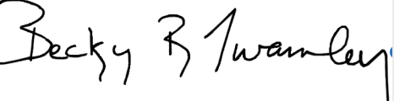
Becky R. Twamley, RPh, MPS
Executive Director, WeARE-The Clinic, Brainerd MN
Board Chair, RHA

