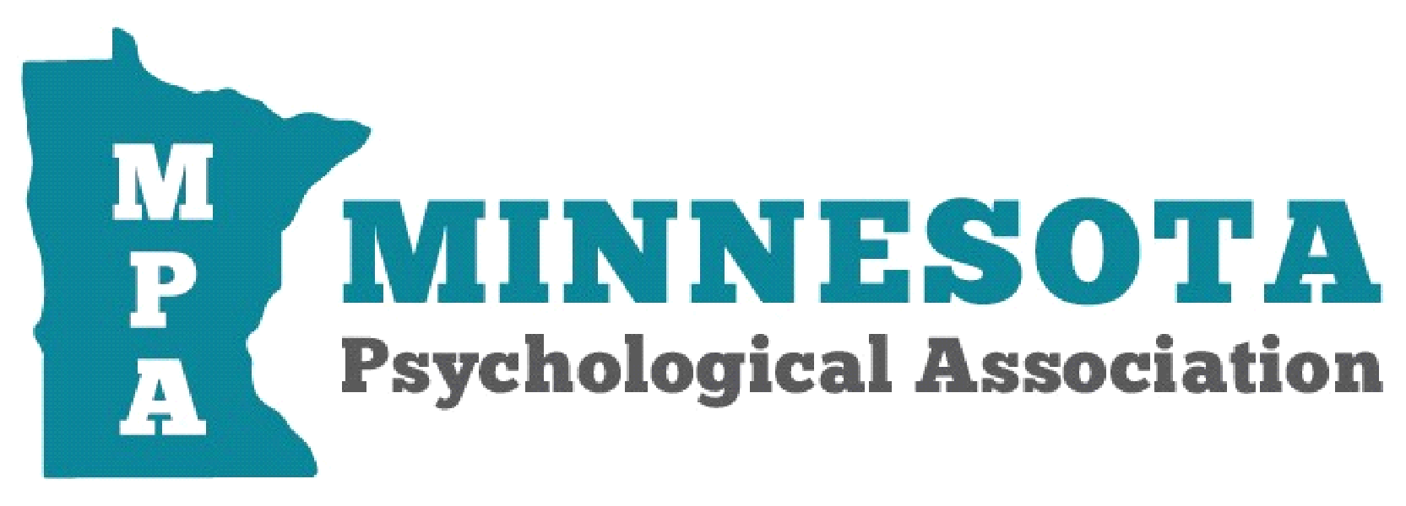
From: Minnesota Psychological Association
To: Chair Liebling and Committee members
Minnesota Health and Human Services Finance Committee
June 15, 2020
Re: SC7625-8

Chair Liebling and Committee Members:

The leadership of the Minnesota Psychological Association would like to support efforts to extend waivers related to telemedicine for Minnesotans. In a recent survey of 664 Minnesota mental health providers, eighty percent of providers indicated that they are currently providing a variety of telehealth services to all or almost all of their patients. Further, they indicate that 11% of clients are currently being served through audio-only telephonic services. It is crucial that these services continue in order to maintain continuity of care with 63% of providers offering audio-only services to ongoing patients and 28% offering services to new patients. Providers resoundingly endorse that services provided by video telehealth and audio-telehealth are of the same or better quality as in person care with 86% reporting that services were of equal or better quality for video services and 67% reporting audio services to be of the same or better quality. Seventy-two percent of these providers indicate that the use of video telehealth services expanded or greatly expanded access to care while 62% report that audio-only services had similarly expanded access to care.
This is an extraordinarily stressful time for Minnesotans, and it is crucial that they continue to have access to mental health and substance abuse services provided through telehealth. Considering a consensus of public health experts and infectious disease specialists state that COVID-19 is likely to go through several waves of infections, with subsequent increases in hospitalizations, it is also very likely that the individuals who need mental health services will also go through changes in their ability to engage in in-person appointments in a safe manner. Access to health and mental health services continues to be a major problem for communities outside of the metropolitan centers. Providers have been able to expand access to care while maintaining its quality using audio and video telehealth services. Please support the continuance of these services to ensure Minnesotans have access to quality mental health services.

Sincerely,

Willie Garret, MS, LP, EdD
President, Minnesota Psychological Association
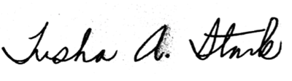
Trisha Stark, PhD, LP, MPA, MJ
Federal Advocacy Coordinator and Legislative Chair
Minnesota Psychological Association

