Longfellow 45-15
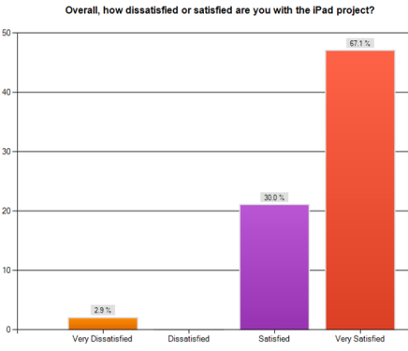
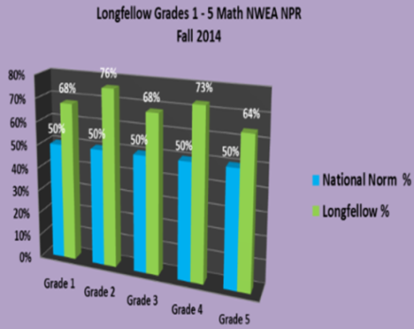
District Wide Option Elementary
ISD 535
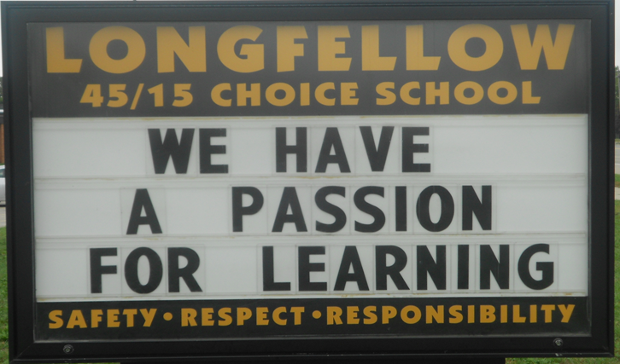
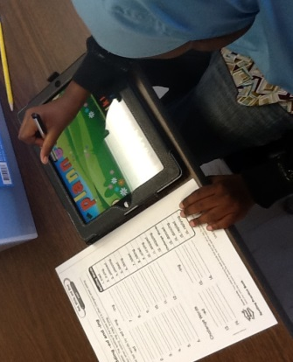
Rochester, Minnesota
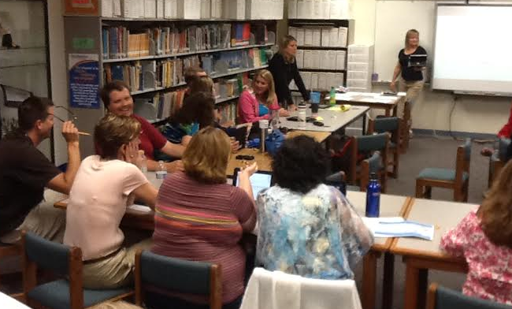
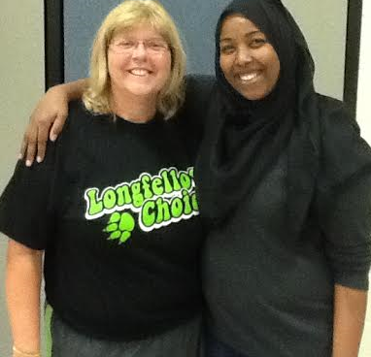
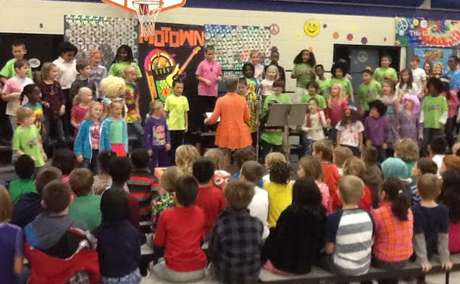
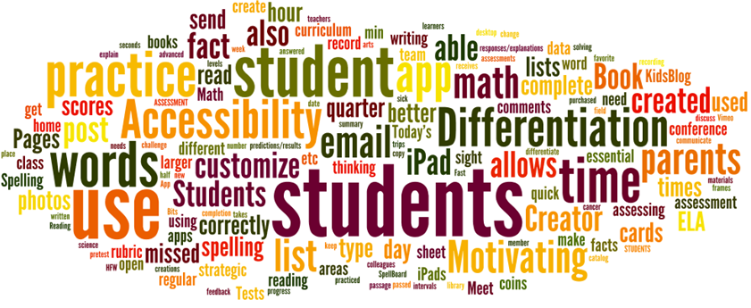
Longfellow Achievements

- Since 2010, Longfellow students in four ethnicity subgroups (Hispanic, Black, Asian/Pacific Islander and White) categories have outperformed state proficiency rates in the same four subgroups 95% of the time on MCA reading and math assessments.
- Longfellow received the Minnesota Campaign for Achievement (MINNCAN) award in 2013 for outstanding Latino and and Black student performance.
- Longfellow received the Minnesota Business Partnership Future’s Award in 2011 representing greater Minnesota for achievement gap reductions.

Key Attributes of Longfellow Success

- 45-15 instructional calendar
  - Currently in our 19th year as a year-round school.
- All day, every day kindergarten for over 10 years.
- Data collaboration team meetings every sixth day for extended periods of time that are inclusive of all staff that work with grade level teams.
- Annual book studies for staff.
  - Focus, by Mike Schmoker
  - The Element, by Sir Ken Robinson
  - Conferring with Readers, Jennifer Serravalo and Gravity Goldberg
- Building and enhancing technology throughout the school.
  - 1:1 school-wide in 2014-2015.
  - Developing staff development district wide.
- Tiered instruction models for reading and math throughout the day in every grade.
- Full-time physical education.
- Extracurricular opportunities for students.
  - Jump Rope Club
  - Jump Rope Team
  - Hip Hop Dance Club
  - Chorus
  - School Play
- Breakfast in the classroom.
- School-wide behavior plans and character education (gold slips, weekly character assemblies and behavior data).
- Empowering staff to lead through humanizing, professional relationships.
- Creative curriculum development, implementation and progress monitoring.
- Staff stability.
- Transforming staff meetings to learning workshops.
- Instructional coach/technology integrationist on site.

