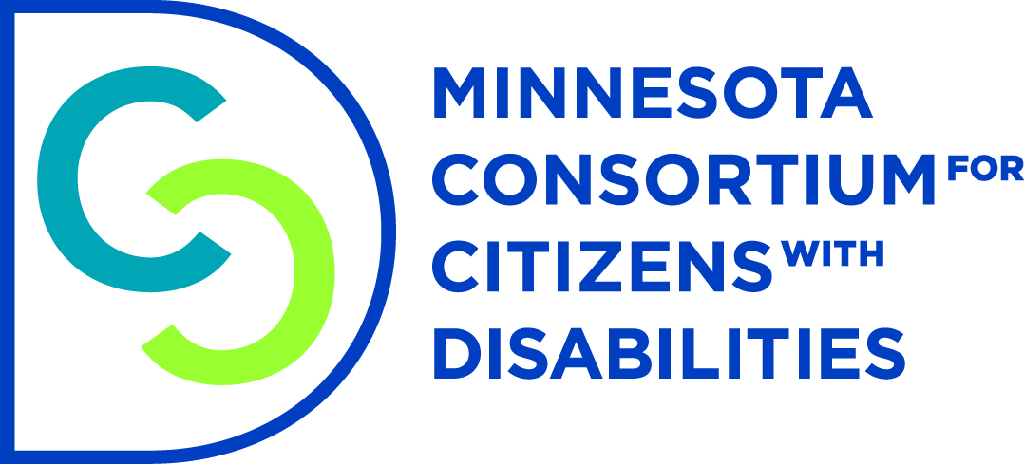

Advancing Independence of People with Disabilities: Fix the Spenddown

My name is Rik Seiler and I live in St. Paul. I sustained a traumatic brain injury in 2014 when a car slid into me on an icy patch of Hwy 169 in Shakopee. I had just rescued a 19 year old driver whose car had flipped on that same patch of ice when I was hit. After a 2 month induced coma I had to learn to talk, swallow and eat all over again. A series of infections further complicated my recovery and left me with permanent physical disabilities in addition to my brain injury.
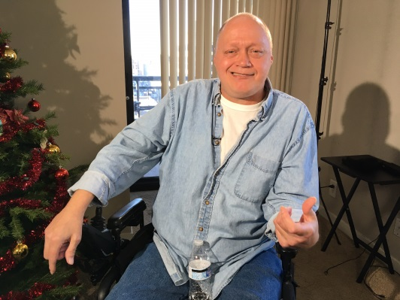
Today, I have limited mobility of my arms and legs, suffer vertigo, short-term memory loss and have a hard time staying organized. It is humbling to admit I now need help paying my bills when I used to be able to balance my checkbook in my head.

I am thrilled that I have regained my independence with the help of Medical Assistance CADI waiver with PCA services, medical transport, meals and an Independent Living Skills worker. I live on about $1,000/month from Social Security Disability Insurance which I paid into working construction for 25 years. But, because this is over the $990 poverty level I am expected to pay all my medical bills until I have just $792/month to live on. It feels like I am being penalized for working hard my whole life and paying into Social Security.

I am only able to afford my rent through the generosity of others. One day soon that will end and I am worried that I won’t be able to find housing I can afford and pay my spenddown. It makes no sense that a program meant to help me live independently puts my very independence at risk by leaving me with so little income to live on.

Please fix the spenddown so people with disabilities like me can keep more of our social security income to pay rent and other living expenses. I went from being a rescuer at the scene of an accident to someone who now needs a helping hand so I can take care of myself and live independently.

Please Fund HF 225

