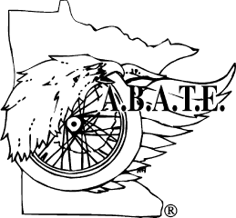
A.B.A.T.E. of MINNESOTA, INC.

P.O. BOX 6

MARSHALL, MN 56258-0006
(507) 487-5000 or 1-800-224-6570

American Bikers for Awareness, Training, & Education

HF 533
Start Seeing Motorcycles special license plates establishment and appropriation

American Bikers for Awareness, Training, and Education (ABATE) of Minnesota supports the establishment of a motorcycle awareness license plate.

Unlike many other specialty plates, these plates have a message that would reinforce the importance of driver responsibility when operating a vehicle on our roads and highways. ABATE of Minnesota believes that a subtle reminder to “pay attention” while driving will be beneficial to all roadway users.

With the advancements in digital license plate design and manufacture, the costs are minimal. This bill also covers those costs and the use of these plates is totally voluntary for any who choose this option when renewing their vehicle license plates on all road vehicles up to a one ton truck. Motorcycle owners typically own multiple vehicles and we expect these plates to be very popular.

ABATE of Minnesota asks you to please support HF 533.

Thank You,

Mack Backlund
State Coordinator
ABATE of Minnesota
763-226-9195
statecoordinator@abatemn.org

