March 14, 2019

House Early Childhood Finance and Policy Committee
State Office Building
100 Rev. Dr. Martin Luther King Jr. Blvd.
St. Paul, MN 55155

Dear Members of the Minnesota House Early Childhood Finance & Policy Committee:

Representing over 1,000 pediatricians in the state, the Minnesota Chapter of the American Academy of Pediatrics (MNAAP) strongly supports HF 2111, a bill to provide funding to support and expand Reach out and Read.

Reach out and Read is an important program that incorporates books into primary care, encourages families to read aloud together, and provides a platform for discussions about the importance of early literacy in the first five years of life – a critical window of rapid brain development that does not occur at any other time.

Children who hear fewer words during early childhood start school developmentally behind their peers and may never catch up. Research shows that in families who are served by Reach out and Read, parents are twice as likely to read to their children, and children’s language development scores are higher on vocabulary tests compared to those who aren’t served by the program.

The American Academy of Pediatrics has declared literacy promotion to be an "essential component of pediatric care" for all children and recommends Reach Out and Read as an effective intervention to engage parents and prepare children to achieve their potential in school and beyond.

We urge you to pass HF 2111 and invest in improving literacy of Minnesota’s children by expanding the Reach Out and Read program to all communities and to all children and their families in Minnesota.

Sincerely,
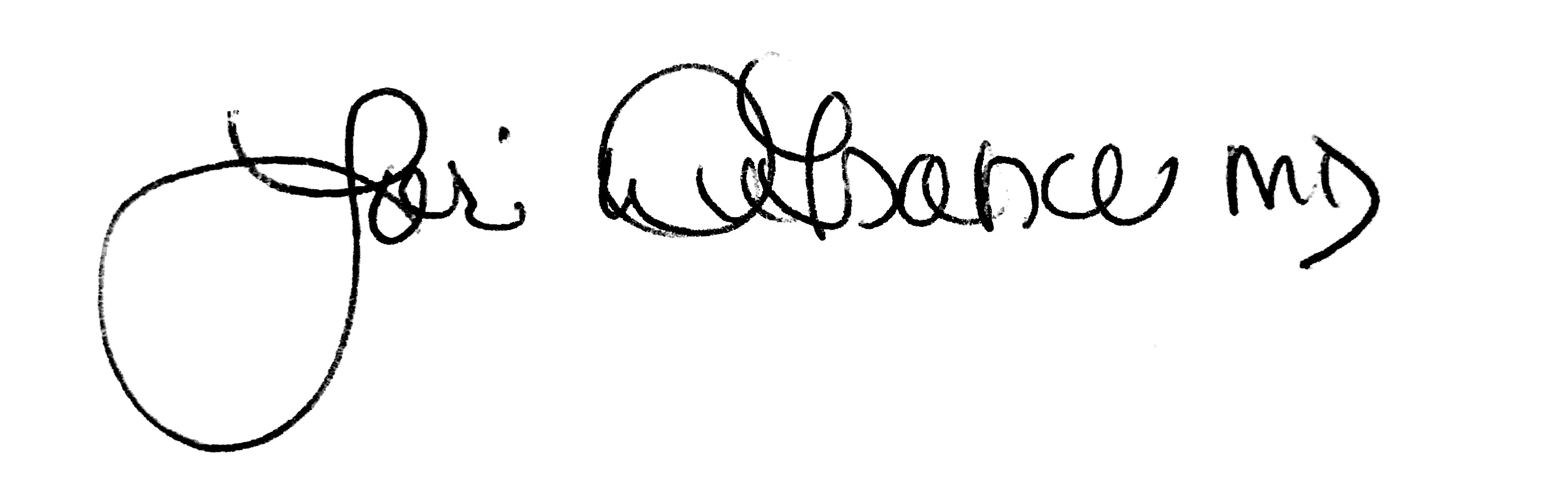
Lori DeFrance, MD, FAAP
President, Minnesota Chapter of the American Academy of Pediatrics

