**Advocating for Fair Reimbursement for**

**Chemical Dependency Treatment Services**

**Who We Are**

* FROG stands Fair Reimbursement and Outcomes Group. We are a coalition of advocates from all over Minnesota who are committed to ensuring the availability and sustainability of chemical dependency treatment services for residents of Minnesota.
* Minnesota is a leader in providing quality care for those suffering from addiction, with over 350 community based agencies and providers and workforce of over 20,000 serving over 50,000 on an annual basis.
* The need for addiction treatment is even greater today in light of the opioid and heroin epidemic ravaging our communities, families and children.
* There is shortage of access to chemical dependency treatment services, and access is diminishing given the widening gap between the unchanging reimbursement rates and increasing cost for delivering care.
* We are seeking a 5% rate increase in 2017 and a 2.5% increase in the remaining three years while we work with DHS to implement reforms to the substance abuse treatment system.
  + While medical inflation has increased over 100% over the past 20 years, reimbursement rates for chemical dependency treatment have increased only 13%.

**What We Do**

* + - Minnesota’s chemical dependency treatment providers offer a continuum of addiction treatment services spanning residential/inpatient treatment, outpatient services, and medication assisted treatment.
    - Minnesota’s chemical dependency treatment providers treat chemical dependency and co-occurring mental health disorders that impact 1 in 3 families in Minnesota.

**Return on Investment**

* Estimates are that addiction costs the United States approximately $400 billion per year in health care and public safety costs and $7 billion per year in Minnesota alone.
* Studies have shown a 12:1 return on investment for chemical dependency treatment1. In other words, for every dollar invested in chemical dependency treatment in Minnesota, the state realizes a return of $12 in health care, criminal justice and societal costs.

1 National Institutes of Health, National Institute of Drug Abuse, Cost Effectiveness of Drug Treatment, 2016

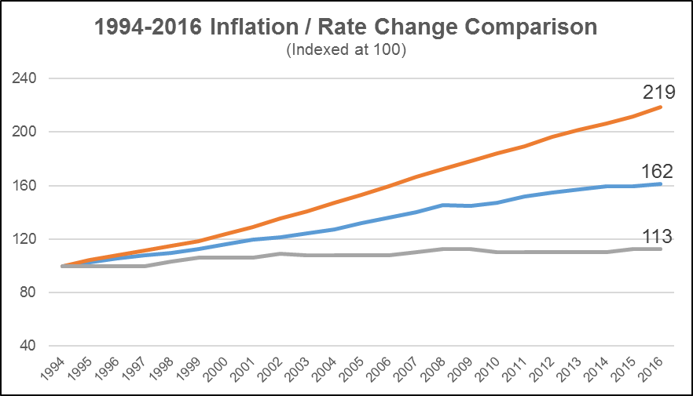

**CCDTF (what we are paid**

**CPI**

**Medical Care Inflation**