“Mythbusting”
Student Free
Press Laws
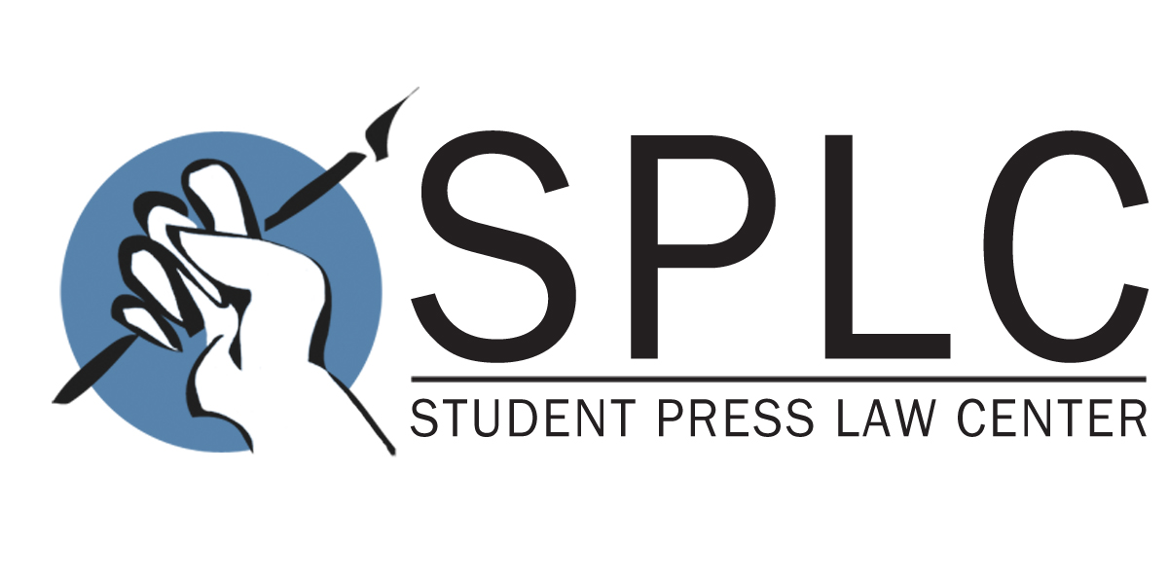

Since 1974, the Student Press Law Center has been the leading source of information about legal issues impacting the student media. The legal staff and attorney volunteers of the SPLC publish the widely used reference text, Law of the Student Press, recognized as the nation’s most comprehensive compendium of legal research about student media.

The SPLC monitors trends in the law of student media and has studied the operation of state “student free press” laws in the seven states (Arkansas, California, Colorado, Iowa, Kansas, Massachusetts and Oregon) with statutes that give students enhanced press freedom above the bare constitutional minimum recognized by the Supreme Court in Hazelwood School District v. Kuhlmeier (1988). The SPLC has been involved as a provider of information when advocates have sought to enact free-press statutes in their states, and is familiar with the recurring arguments raised by lobbyists for school administrators. These arguments almost always are based on “urban myths” that exploit misperceptions and stereotypes.

Myth: Students will commit libel, invade privacy, and otherwise injure people if left to publish without tight administrative control.

Reality: Eight states (Arkansas, California, Colorado, Iowa, Kansas, Massachusetts, North Dakota and Oregon) have laws under which K-12 public-school students are given the ability to publish the lawful and non-disruptive editorial content of their choice. There is no evidence of any greater incidence of libel, invasion of privacy or other injury in those states – even California, which has had such a law for nearly 40 years. Combined, these states have 160-plus years of experience with student press freedom; if such statutes led to damaging results, 160 years would be ample time to find out. The reality is that: (1) schools almost never are sued over the content of student publications, (2) schools almost never use their censorship authority to remove truly injurious content, but rather, use it to remove material that calls attention to the school’s shortcomings, and (3) even a student free-press statute would not prevent a school from dealing with material that is libelous or otherwise not legally protected speech. Nor have anti-Hazelwood laws resulted in a floodtide of student journalists suing their schools. A study published in 2013 in the Maine Law Review could find only six instances – three in California, two in Massachusetts and one in Iowa – in which a student free-press statute had ever been raised in litigation. The reality is that, by clarifying the bounds of school censorship authority, such statutes probably avoid more litigation than they enable.

Myth: An “anti-Hazelwood” statute gives students the “same rights” as full-time professional journalists.

Reality: Not at all. Reversing the impact of the Supreme Court’s 1988 Hazelwood ruling merely restores the sensible balance that existed before 1988 – the standard set by the Court in Tinker v. Des Moines Independent Community School District (1968). Under Tinker, the school may prevent or punish speech that threatens a “substantial disruption” of school activities – something more than just a strong exchange of differing opinions. Tinker is very far from being an “anything goes” standard – in fact, it is the standard that applies today to students’ T-shirts, hairstyles and other “non-curricular” forms of speech, to which schools have become accustomed over the last 46 years. Rolling back Hazelwood merely gives a student the same (limited) level of First Amendment protection on the editorial page that she has on the T-shirt she wears to school. To illustrate: A professional magazine run by adults can publish an editorial advocating recreational drug use by children and be protected by the First Amendment. The same column would be unprotected speech if offered for publication in a student newspaper, even under the Tinker standard.

Myth: Administrators need to review the paper to minimize the risk of the school district being sued.

Reality: A search of the Westlaw© and Lexis© case law databases shows a grand total of zero published cases in which a school district was held responsible for what students wrote in a student newspaper, magazine or yearbook. While there is the rare nuisance suit that quickly settles or is dismissed, the fact is that people almost never file suits over the content of student newspapers: it’s nearly impossible to show that a person’s life was ruined by a story in a student newspaper, and the public understands that journalists-in-training are going to make errors. Other school activities are exponentially more dangerous than uncensored journalism – like high school football, which is blamed for an average of twelve student deaths nationwide each year. Yet no one advocates that students be forbidden from tackling each other because someone might get hurt, or even killed. We accept that students must run the risk of physical contact so they can learn to play the game properly, and the same rule makes sense in journalism. As a matter of historical fact, a school is more likely to be sued – and sued successfully – for violating students’ First Amendment rights by censoring a newspaper than by allowing the newspaper to publish uncensored.

Myth: Administrators need to review the paper because the school district is legally liable for everything in it.

Reality: Although lawsuits are so rare that this legal principle has almost never been put to the test in the high-school context, in the handful of lawsuits against college publications, the courts have unanimously said that public colleges can’t be held financially liable for students’ editorial content if they are barred by law or regulation from censoring the content: no control, no liability. The only known case in which this issue has been adjudicated at the high school level – Sisley v. Seattle Public School District No. 1, a Washington state trial court ruling in a 2011 libel suit – agreed that a public high school is not liable for what its students publish in a student-controlled newspaper. Increased school control over editorial content maximizes, not minimizes, whatever slight risk of legal exposure exists. (Several anti-Hazelwood statutes, notably those in Kansas and Oregon, expressly insulate schools from liability for the content of student media.)

Myth: A principal reviewing – and reserving the right to change – a student newspaper is just doing what professional newspaper publishers do.

Reality: Actually, what professional newspaper publishers do is hire well-trained editors and get out of their way. Most publishers – like most principals – are professional managers, not journalists, and (like principals) they don’t have the expertise or the time to be playing “super-editor.” And – unlike in a professional newspaper – the principal’s policies are the primary subject of the student newspaper’s coverage. If the publisher of a professional newspaper is personally involved in a story, all accepted codes of ethics require that the publisher remove himself from reviewing that story. A principal who changes or cancels a story about her own administration is violating basic ethical standards – and is teaching students that ethics don’t matter. School administrators often allege that they need censorship authority to “teach journalism,” but school officials in practice rarely give educationally valid reasons for vetoing stories. Typically, students are told nothing more than, “You are making the school look bad,” which has nothing to do with the teaching of sound journalism.

Myth: Administrative control over student media is a widely approved practice.

Reality: No reliable research indicates that administrative control over the content of student media is a “state of the art” practice. In a survey of 600 attendees at the 2013 National High School Journalism Convention by Kent State University researchers, fully 82 percent reported that no administrator pre-approves editorial content before student media is published or aired, so censorship is hardly a universally accepted reality. Every authoritative group involved in journalism education and training has gone on record condemning the Hazelwood level of school control as educationally unsound. During 2013, the 25th anniversary of the Hazelwood decision, resolutions calling for schools and colleges to cease reliance on Hazelwood were unanimously enacted by the Society of Professional Journalists, the Journalism Education Association, and the Association for Education in Journalism and Mass Communication. These are the largest membership organizations in the country representing, respectively, working professional journalists, high school journalism educators, and college journalism educators. The wording of the SPJ resolution exemplifies the organizations’ sentiments: “[I]t is well-documented the Hazelwood censorship clause impedes an educator’s ability to adequately instruct and train students in professional journalistic values and practices, including the right to question authority and investigate performances of governance.” School administrators would not overrule the leading standard-setting body in any other area of education – they would not tell school nurses how to administer shots contrary to protocols set by the national nursing association – and they should not do so in the field of journalism.

