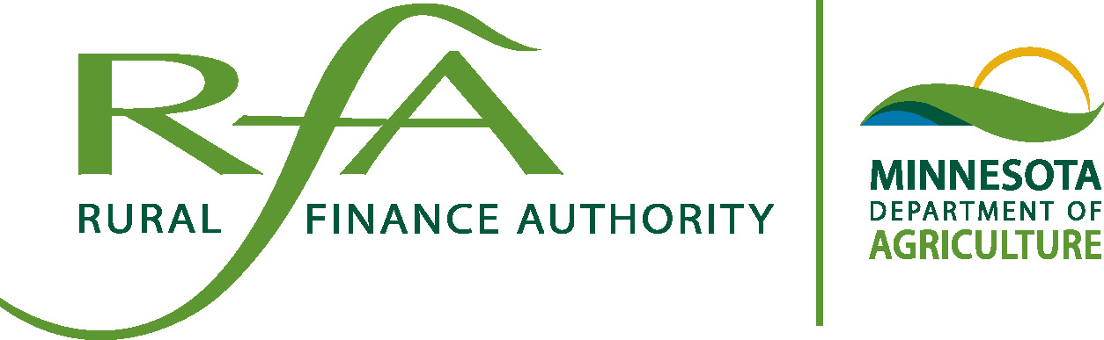
Rural Finance Authority (RFA)

History:

The Rural Finance Authority (RFA) was established in 1986 to administer a program under which the state partners with agricultural lenders to provide low cost financing to Minnesota farmers. The initial program was designed to help lenders and borrowers restructure farm real estate loans that had become under secured. The RFA has since grown to include a variety of unique options, including the Beginning Farmer and Seller Assisted Programs; the Agricultural Improvement Loan Program; the Livestock Expansion Loan Program, and the Restructure Loan Program.

Program Purpose

Rather than making loans directly to farmers, the RFA partners with more than 400 community banks and members of the Farm Credit System to extend credit. Farmers borrowing funds through the RFA pay lower interest rates than they would otherwise pay. This makes it easier for the farm family to get the funding necessary to acquire a farm or make on-farm improvements. The public-private partnership improves the farmer’s cash flow and allows greater access to credit since the lender shares the risk with the RFA.

The RFA Board

The Minnesota Rural Finance Authority is governed by an eleven member board. The board of the authority consists of four agency commissioners (Agriculture, Commerce, Employment and Economic Development, Minnesota Management and Budget) the State Auditor, and six public members appointed by the governor with the advice and consent of the senate. The commissioner of agriculture is the chair of the board.

The Program is User Financed
Under the program state bonds are authorized to be issued and proceeds of their sale are appropriated under the authority of article XI, section 5, clause (h) of the Minnesota Constitution. The purpose of the bonds issued is to purchase participation interests in agricultural real estate loans.
Principal and interest received on loan participations are deposited into a fund for the redemption of bonds issued under the various programs and may not be used to fund further loans. Annually, on December 1, these funds are transferred to the Department of Management and Budget Debt Service Fund for bond redemption and interest payments on the bonds for the following year.

RFA has a strong record of success. Through June 30, 2015 the RFA programs had achieved the following benchmarks:

- Total of 2,888 loans issued under the program for $215 million;
- Loan Losses of $506,322 on 20 loans since 1986;
- Outstanding Loan Balance as of $50.8 million; and
- Represents 417 active files

Figures do not include Aggie Bond
____________________________________________________________________________________________________

RFA uses bond funds to offer farmers the following programs:

- Beginning Farmer Loan and Seller Assisted - program is aimed at lower equity individuals who intend, over time, to have farming as their principal occupation. The purpose is to enable the beginning farmer to purchase farm real estate.

- Agricultural Improvement - program provides financing for improvements to a farm. These improvements can be for any agricultural purpose including grain handling facilities, machine storage, livestock buildings and improvements, wells and manure systems.

- Restructure II - program helps farmers restructure their debt with their local lender when they are having trouble with cash flow. Only debt of an agricultural nature is eligible.

- Livestock Expansion - program creates affordable financing for new, state-of-the-art improvements for livestock production, including the purchase and construction or installation of improvements of land, buildings, and other permanent structures, including equipment incorporated in or permanently affixed to the land, building or structures.

Additional Information

The RFA will purchase a forty-five percent (45%) interest in the lender’s first mortgage (up to $400,000) to an eligible farmer under the Beginning Farmer, Seller Assisted and Agriculture Improvement Programs. This participation interest is set up on a reduced interest rate to improve the farmer’s cash flow and to share the risk of making the loan with the lender.

Eligible borrowers under the Beginning Farmer and Seller Assisted Program must have sufficient education, training or experience to succeed in the type of farming operation they intend to pursue. They must not have a total net worth exceeding $450,000 indexed for inflation. They must agree to enroll in a farm business management program, and they must agree to carry credit life insurance for the amount of the loan.

The RFA will purchase a forty-five percent (45%) interest in the lender’s first mortgage (up to $525,000) to an eligible farmer under the Restructure II and Livestock Expansion Loan Program. They must not have a total net worth exceeding $848,000 indexed for inflation.

The RFA and lender become partners and each owns a pro-rata share of said mortgage. Loan amortization may be scheduled on a term of 15, 20, 25 or 30 years.

Additional Information can be found at: MDA Website: www.mda.state.mn.us In accordance with the Americans with Disabilities Act, This information is available in alternative forms of communication upon request by calling 651-201-6000. TTY users can call the Minnesota Relay Service at 711 or 1-800-627-3529. The MDA is an equal opportunity employer and provider.

