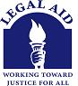

Legal Services Advocacy Project
Mid-Minnesota Legal Aid
2324 University Avenue, Suite 101
St. Paul, MN 55114
651-842-6909

March 13, 2019

The Honorable Sandra Masin
State Representative
Minnesota House of Representatives
543 State Office Building
100 Rev. Dr. Martin Luther King Jr. Blvd
St. Paul, MN 55155

Re: HF 1744 – Family Law Mediation Task Force

Dear Representative Masin:

Thank you for authoring HF 1744, which establishes a Family Law Mediation Task Force and which is before the House Government Operations Committee tonight. The Legal Services Advocacy Project (LSAP), the statewide advocacy arm of the Minnesota Legal Services Coalition (Legal Aid), writes to offer its support for this legislation and its appreciation and support of an amendment to add the Minnesota Legal Services Coalition to the bill.

LSAP provides legislative and administrative advocacy on behalf of the six regional civil legal services programs in Minnesota, which comprise the Coalition and collectively cover all 87 Minnesota counties and provide representation, advice, and community education to low-income Minnesotans, older Minnesotans, and Minnesotans with disabilities. In communities across the state, Legal Aid works with tens of thousands of clients annually and offers online help and resources to nearly 370,000 others.

This bill addresses the important issue of how to resolve disputed dissolutions that involve custody determinations for children. The development of mediation alternatives when custody is disputed would go a long way to avoid emotionally difficult and financially costly legal battles that never serve the best interests of children.

Having the Legal Aid as a participant will add the voice of low-income Minnesotans experiencing the difficulties of divorce as they struggle with the impact on their children, and ensure their ability to afford any mediation services that emerge as a model as a result of the task force’s work.

We support and appreciate the addition of the Minnesota Legal Services Coalition to task force membership and urge the committee to pass HF 1744.

Sincerely,
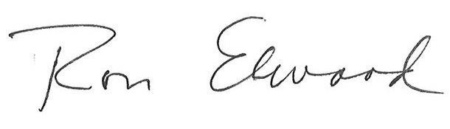
Ron Elwood
Supervising Attorney

