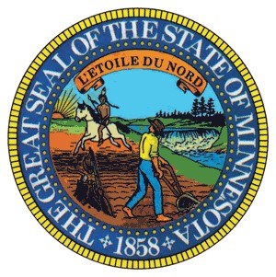
Minnesota House of Representatives
Tina Liebling
State Representative
District 26A

Chair: Health Finance and Policy Committee
Date: February 10, 2022

To: Rep. Mike Freiberg, Chair, Preventive Health Policy Division

From: Rep. Tina Liebling, Chair, Health Finance and Policy Committee

RE: Bill Referrals

As of Thursday, February 10, 2022, the following bill is hereby referred to the Preventive Health Division.

HF3153 (Morrison) Tobacco and nicotine cessation treatment medical assistance coverage expanded.

CC: All Chief Authors
All Chief Author’s LAs
Rep. Joe Schomaker, Health Finance and Policy Committee GOP Lead
Rep. Glenn Gruenhagen, Preventive Health Division GOP Lead
Carl Hamre, House Index
Ryan Inman, Revisor of Statutes
Jeremiah Wingstedt, GOP Research
Lorie Cousineau, GOP Research
Joe Durheim, DFL Research
Erik Anderson, DFL Research
Elisabeth Klarqvist, House Research
Joe Harney, House Fiscal
Sean Rahn, Executive Director Majority Caucus
Chris McCall, Legis

