Red Lake Tribal Nation and White Earth Tribal Nation Medical Cannabis bill HF3162

HF 3162 is a bill that will:

1. Authorizes each Tribal Nation and the state of Minnesota the ability to enter into a Medical Cannabis Compact:
a. The compact details are spelled out in the bill;

2. Addresses the transportation of samples for testing from the Tribal Nations facility within the Tribal Nations to the testing laboratory in St. Paul;

3. Addresses the transportation of the medical marijuana product off of the Tribal Nation and into the state of Minnesota;

4. Defines a Tribal Medical Cannabis program; and

5. Defines a Tribal Medical Cannabis patient.

Further background information on efforts of Red Lake and White Earth Tribal Nations Bill, HF3162:
1. The Tribal compact language was presented in committee during last year’s session;
2. The current statute spells out the transportation of products and samples;
3. Tribal Nations have inserted language to the current statutes regarding products and transportation from the Tribal Nations into the state of Minnesota.

If you have any questions, please contact:

Red Lake Lobbyist White Earth Lobbyist
Anna Marie Hill Bill Haas
Annamarie.Hill@redlakenation.org bill@haasmb.com
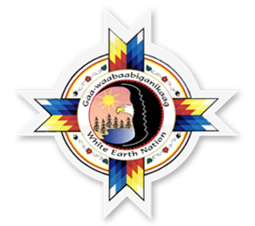
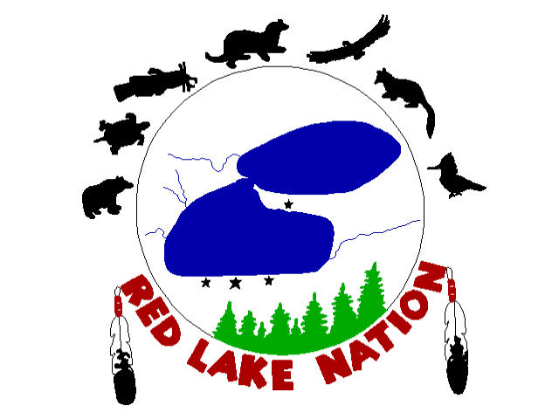
(651) 470 3178 (612) 751 7968

