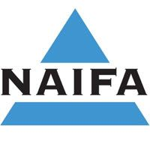
March 29, 2022
Rep. Zack Stephenson, Chair Committee on Commerce Finance and Policy 509 State Office Building St. Paul, Minnesota 55155
Dear Chairman Stephenson,
I am writing on behalf of the National Association of Insurance and Financial Advisors (NAIFA) in support of H.F. 4394. NAIFA represents licensed insurance agents and financial advisers across Minnesota.
H.F. 4394 establishes a best interest standard of conduct for annuity recommendations and sales. The best interest standard requires producers and insurers to act in the best interest of annuity purchasers and not put their financial interests ahead of the consumer's. A substantial percentage of NAIFA members sell annuities.
This legislation strikes the appropriate balance between protecting consumers, promoting market competition, and avoiding over-regulation, in turn ensuring customer choice in competitive products and trustworthy options for retirement planning. The updated NAIC model and the best interest standard has broad support from the financial services community, producers, and insurers alike. NAIFA members subscribe to a code of ethics that requires putting our clients' interests first. We support establishing a consistent and workable best interest standard for financial professionals and hope Minnesota will to join the 21 other states that already adopted this model.
Thank you for authoring this legislation and we encourage the Committee to support it.
Sincerely,
/s/
Corey Anderson, Chair Government Affairs Committee
600 State Street, Suite A Cedar Falls, Iowa 50613 Phone: 651.366-6091 info@naifa-mn.org
National Association of Insurance and Financial Advisors - Minnesota

