Dawn Kovacovich Testimony – HF2847 March 17, 2023
To: Minnesota House Human Services Finance Committee Chair Noor and members of the Committee:
It is with regret that my daughter, Laura Kovacovich, and I are unable to testify in person regarding our position on this bill, which threatens to eliminate Laura’s right to work at her own pace and ability. The impacts of this bill could potentially devastate the quality of life for our daughter and over 5000 people with disabilities that limit their capability to work in at a competitive level. We very much appreciate your consideration of our testimony.
The proposed amendment to Section 1 (subdivision 6) specifically outlines prohibition of special certificates for what is often referred to as “subminimum” wages. Contrary to negative publicity, the certificates are a special needs accommodation based on individual productivity, commensurate with prevailing minimum wage. These wages are not “subminimum” to the output that these special employees are able to produce. It is a provision that allows people who are typically unemployable to have the choice to work at their own pace and ability. Without this provision, most of these people will no longer be able to work AT ALL. Additionally, the people who utilize this program typically qualify for other government programs to support their living expenses and do not depend on this income to live.
Scattered throughout the proposed changes to this bill are references to “prohibited procedures”, person-centered planning, grant initiatives for people who are capable of competitive employment, and case management requirements for a non-disability-specific setting. Nowhere in this bill are the needs and desires of people who require constant, supportive supervision addressed. For many of these people, person-centered planning MUST include specialized disability-specific options in order to meet ADA requirements to appropriately meet their needs. The social/emotional needs of this subset of the disability population are also far different than the needs of nondisabled and mildly disabled people and simply cannot be replicated in a competitive setting.
It needs to be clearly understood that employment under a 14c special wage certificate is a CHOICE, as is employment in a specialized disability center program with trained supervisory staff. Prohibition of this CHOICE is extremely discriminatory to people like my daughter who will never be able to work successfully outside of this model due to the nature and severity of her disability. The option to work in a competitive setting for competitive wages has never been compromised or limited by allowing these individuals the right to choose what works for them. No one benefits from this.
We do not view this as a wage issue. It is a quality-of-life issue. We cannot fathom why anyone would want to eliminate the choice for someone to feel like a productive member of society, working at jobs specifically tailored to meet individual abilities; enjoying the camaraderie gained through having a daily routine among people with similar needs and interests; and having the opportunity to reach full potential as an adult in a setting that works best for that person.
There is no data that shows any economic or social benefit to elimination of this program. Forcing employers to pay minimum wage or higher to individuals who are not able to meet base-line expectations for job performance, while at the same time often needing extensive supervision and other accommodation, has already rendered serious consequences. Rather than increasing the rate of employment for people with disabilities, it has led to closures of already underfunded programs and will continue to do so. This has also led to an increase in requests for full time PCA support services and behavior support for people whose basic human needs for accomplishment and belonging are not met. It is neither feasible, nor realistic to expect 1:1 long-term job coaching in a competitive work environment to be successful for this subset of the population. This bill automatically relegates them to adult day care, which is highly discriminatory to those who would prefer to work. The long waiting lists for center-based programming, PCA care, and 1:1 job coaching at a time when positions for Direct Service Professionals cannot be filled are indications that ending special wage flexibility and the imminent closure of specialized work centers for the disabled would be a tragic mistake. The burden is transferred to families who need to drop out of the work force to care for their family member.
Our daughter has absolutely blossomed in her specialized work center, bubbling over with enthusiasm for how much she loves her jobs, her job supervisors, and her coworkers. The environment where she works provides the critical predictability, adapted schedule, and developmentally appropriate activity choices and socialization that she craves. The “nondisabled world” (competitive environment) is overwhelming and unpredictable to her, setting off extreme tantrums and violent outbursts. She does not gain a sense of belonging or have a peer group when she is a minority among the nondisabled. She believes she should have the right to choose what works best for her, just like everyone else.
Although the requests and advice of parent/guardians like myself have often been dismissed as “fear based”, with flippant comments about how we underestimate our adult children, I come to you as a respected Special Education teacher and a life-long advocate for people with I/DD and severe autism. I have served as a board member and involved advocate on multiple national, state, and local committees and agencies. Parent/guardians have every reason to fear for the safety and well-being of our vulnerable adult children, many of whom have cognitive and/or social maturity comparable to very young children. Our voices need to be heard on behalf our loved ones who typically cannot speak for themselves.
Please do everything you can to prevent the elimination of commensurate wages and specialized work centers for people with severe autism and Intellectual or Developmental Disabilities (I/DD). We specifically request that you delete Article I Section 1.Subd6(a)&(b); Section 3(4)&(5); all of Section 16.Subd1; all of Section 74; and all of Section 75 of SF2934. Thank you!!!
Sincerely,
Dawn Kovacovich Laura Kovacovich
20292 Windhill Drive 311 Birch Avenue (Heartland Homes)
Bemidji, MN 56601 Park Rapids, MN 56470
218-566-8258 kovac@paulbunyan.net
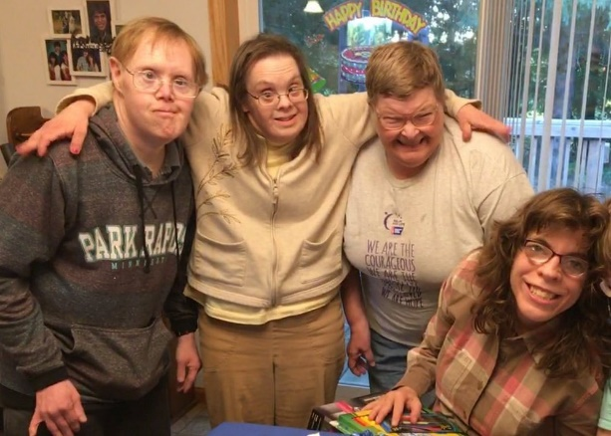

Laura with her housemates, who also work at a Laura showing off some of her work! She is specialized work center for commensurate wages. so proud of her accomplishments!

Laura’s motto: My Work, My Home, My Life - My CHOICE!!!

