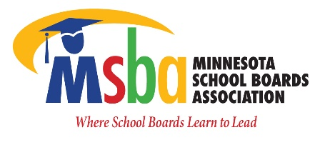
February 7, 2022

Members of the House Education Finance Committee and Rep. Her,

MSBA appreciates your efforts to address the English learner cross-subsidy in the state by authoring HF 2944.
The most recent MDE report confirmed that ELL categorical funding is short by $117.2 million statewide. Districts are spending nearly $177 million on El services and received only $58.6 million in categorical revenue in FY20. As our state has become more diverse, districts have added trained EL staff to serve students at various levels of English proficiency, included sheltered classrooms, co-teaching, dual immersion programs, interpreters, training for regular instruction teachers and instructional materials. Districts have also added services/staff to better engage multilingual families and offered additional extended day and year programs.
MSBA is very grateful for the $2 million provided by legislature in additional EL revenue for the next four years. This is far short of the necessary commitment and was not included in the base. This gap in funding, along with the underfunding of special education and lack of inflation in the general education formula, has put a significant strain on districts’ ability to provide the necessary individual instruction to ensure success for all students.
English Learner (EL) students are eligible for EL revenue for up to seven years. Although additional instruction is required beyond the seven years if student is not yet proficient in English.
Many districts are experiencing increases in EL students and are grappling with an EL cross-subsidy. districts spent $176.9 million on EL services for FY20 and received $58.6 million in EL revenue, leading to a cross subsidy of $118 million for the year. Districts use general fund dollars to cover these cross-subsidy costs, which can result in larger class sizes and fewer course offerings.
Prior to last year’s one-time funding, the EL per pupil funding had not been increased since 2003 – nor adjusted for inflation. With over 70,000 EL identified students in the state, the change this resolution calls for would go a long way in helping districts meet the needs of a growing EL population. Some examples of EL cross-subsidies around Minnesota are:
Albert Lea Area Schools ($1,343,920)
Moorhead Public Schools ($2,843,597)
Minnetonka ($1,103,167)
St. Cloud ($3,109,106)
Rosemount Apple Valley Eagan ($5,610,828)
St. Paul Public Schools ($23,276,340)

To drill down further in one of the above examples, St. Cloud is severely impacted and limited by this cross-subsidy. This large shift of funding dollars from regular instruction to EL inhibits districts like St. Cloud from providing equitable educational instruction, supports and extracurricular opportunities (as compared to other districts). Districts with lower EL do not see the same level of impact. These funds are badly needed in districts already impacted by high rates of poverty (FRL) and diversity. Holding this cross-subsidy steady does not help; it simply prolongs the annual funding shortfall and ensures the effects will continue. The time has come to eliminate the funding shortfall.
Recently, at the MSBA Delegate Assembly, the following resolution was passed 104-8:
MSBA URGES THE LEGISLATURE TO RESOLVE OR PHASE OUT THE ENGLISH LANGUAGE CROSS-SUBSIDY BY 2025.

Respectfully,

Minnesota School Boards Association

